**Homework 3**

**Dipak Bange(djbange@iu.edu)**

**Total: 100 points This section: 15 points**

**Topic: Creating a new database and loading data into it.**

**Step1:**

You must have created a MongoDB cluster in previous weeks. You have to make use of the same cluster here**.**

Using you MongoDB Compass, connect to your MongoDB cluster.

**Step 2:**

Create a new database called “**pokemon_db”**. Inside that, now create a new collection called **“pokemons”.**

**Step 3:**

Now using the MongoDB compass, import the provided **“pokemons.json”** file.

Once you are done with all the above steps. Post a screenshot of your newly created database and collection. Here’s an example screenshot of my MongoDB compass.

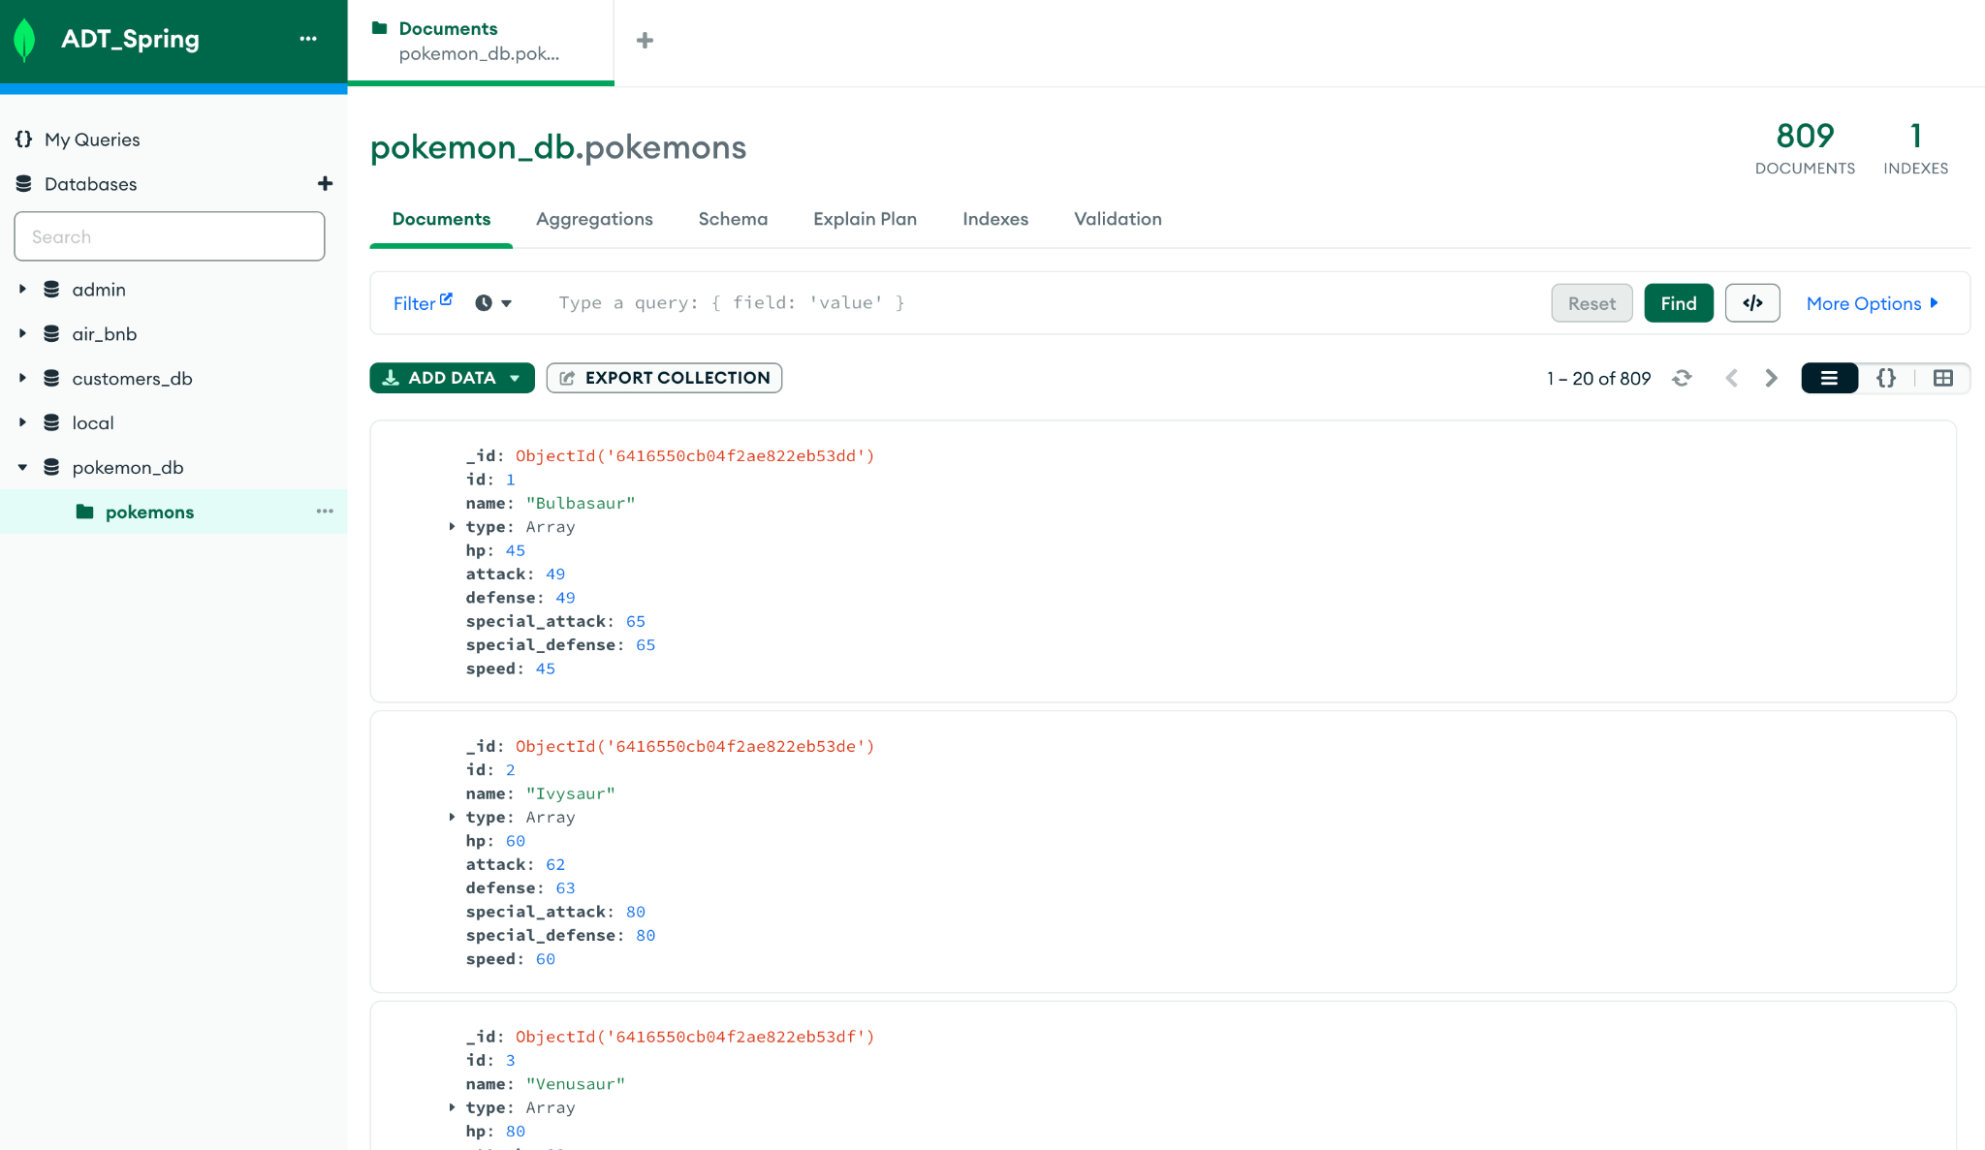

**Your screenshot here:**

**Added Database:**

